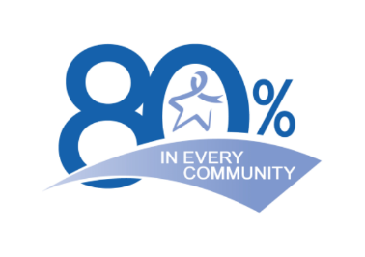
WA State CRC Task Force Meeting- 3.05.2020- Notes

Resources:
- Link to submit patient stories of cost-sharing to the Office of the Insurance Commissioner- https://www.insurance.wa.gov/file-complaint-or-check-your-complaint-status
- 2019 Colorectal Cancer Screening Messaging Guidebook- https://nccrt.org/resource/2019messagingguidebook/

Important Dates:
- Next Survivorship Committee meeting is March 23, 2020 @ 12:30
- Next CRC Taskforce Meeting: July 21, 2020 @ 12:00pm
- Washington State Dress in Blue Day: Colorectal Cancer Awareness Kick Off Event March 6, 2020
  - See attached flyer to find out how to participate
- Oregon Colorectal Cancer Conference: March 20th- REGISTER HERE
- Save the Date: Western Colorectal Cancer Consortium Conference March 26 – 27, 2020 (California Colorectal Cancer Coalition)

Priority Committees and Contacts for Participation:
- Charity Care- Casey Eastman- casey.eastman@doh.wa.gov
- Electronic Health Record- Beth Bristol- Beth.Bristol@virginiamason.org
- Gastroenterologist Partnerships- Casey Eastman- casey.eastman@doh.wa.gov
- Health Plans- Tammy Wild- tammy.wild@cancer.org
- Media- Katie Treend & Anita Mitchell-Isler- katherine.treend@doh.wa.gov and anita@colonstars.org
- Survivorship- katherine.treend@doh.wa.gov-

Guest Speakers:
- Jenica Palmer-ACS- State & Primary Care Health Systems Manager, Portland, Oregon
- Ginny Weir-Bree Collaborative- Director, Seattle, Washington

CRC CME
- Take advantage of this opportunity to hear Dr. Jason Dominitz, the National Director of Gastroenterology for the Department of Veterans Affairs and Professor of Medicine at the University of Washington, discuss the controversies and complexities of CRC screening.
- Access to the presentation: Here
- See attached flyer for more information.

Please see the attached slides for Presentation highlights and committee updates.

If you would like to participate in one of the committees, please contact the lead listed on the slide.

If you have any questions regarding the speaker’s presentations, committees, or anything regarding the CRC Task Force, please don’t hesitate to contact Tammy Wild or Katie Treend.

