Purpose
The purpose of this document is to outline the process and provide resources for Washington WISEWOMAN Health Coaching, to be used by clinics administering the WISEWOMAN program in Washington State. Others may find this resource document useful for Health Coaching. For additional support for Health Coaching for Cardiovascular Health, please contact the Heart Disease, Stroke, and Diabetes Prevention Program at the Washington State Department of Health, by email, at HeartDisease@doh.wa.gov. The health coaching process documented here uses the Great 8 tool from the Washington State Department of Health, available in 27 languages, which can be accessed on the WA Portal’s Cardiovascular Connection site, here: https://waportal.org/partners/home/cardiovascularconnection/great8

Structure of Health Coaching Using 4 Focus Areas of Great 8
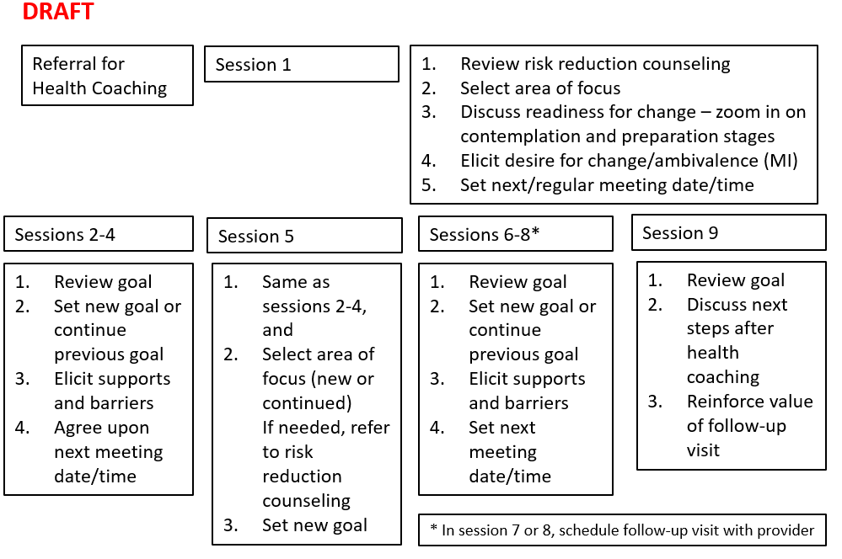

4 Focus Areas of Great 8
 | 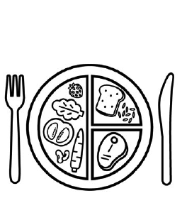 | 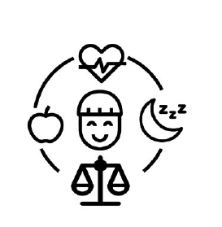
Be Active | Eat Well | Practice Wellness | Steer Clear of Smoking and Vaping

Session 1: Introductory session
After establishing rapport, share 4 focus areas (below).
- Say, these 4 highlighted areas are great places to start with making changes to improve health
- Describe that the goal is to select one of these 4 areas to start, for the first module (4 sessions).
- To reach goal, have a conversation with client engaging them
- Ask – where would you like to focus for the first module (4 sessions)?

Outline of Session 1
- Say – you will have an opportunity to pick a different area to focus on, if you would like to, for the second module.
- Refer back to risk reduction trifold if client is unsure, or asks where to focus from a medical perspective
- Once client selects a focus area, use the assessment tools below
- Before end of session, determine next meeting date and time. Consider a regular, every other week, or two times per month, schedule, to reduce barriers to remembering sessions.
- Give the corresponding 1-page for the focus area the client has identified, ask them to start thinking about what they would like to set as a goal.
- Determine if next meeting will be in person, via telehealth, or on the phone.

Sessions 2-4: Health Coaching – first focus area
- Check in with client
- Review goal
- Set new goal or continue previous goal within focus area
- Elicit supports and barriers
- Agree upon next meeting date/time

Sessions 5: Complete first focus area, select second focus area
- Check in with client
- Review goal
- Select a new focus area (or continue previous focus area)
- Refer back to risk reduction if needed for selecting new or continued focus area
- Set new goal within this focus area
- Elicit supports and barriers
- Agree upon next meeting date/time

Sessions 6-8: Health Coaching – second focus area
- Check in with client
- Review goal
- Set new goal or continue previous goal within focus area
- Elicit supports and barriers
- Agree upon next meeting date/time
- In session 7 or 8, schedule follow-up WISEWOMAN visit

Sessions 9: Final Health Coaching visit
- Check in
- Review goal
- Celebrate success
- Discuss next steps after health coaching – provide resources to community programs
- Reinforce value of follow-up visit
- Thank client for participating

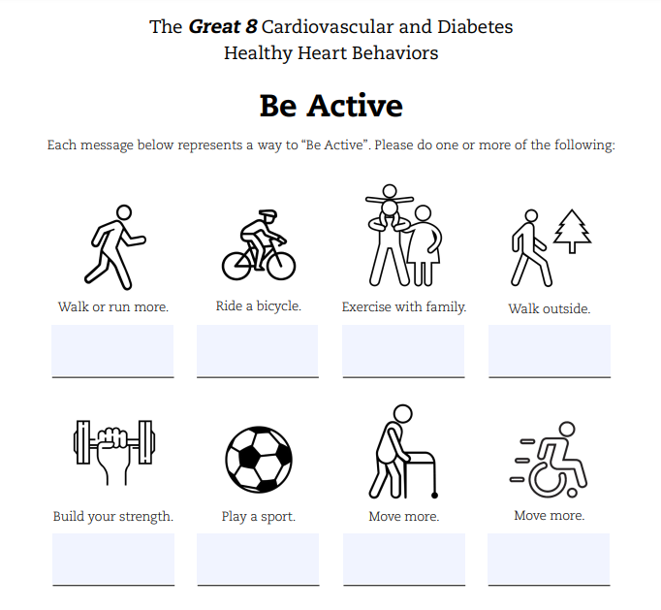
Online resources to support “Be Active”
Active for Life resources for parents of young children in multiple languages
Physical Activity resources from SNAP-Ed
Physical Activity Basics from CDC in English | Spanish
List of “Free Days” at Washington State Parks (no pass required)

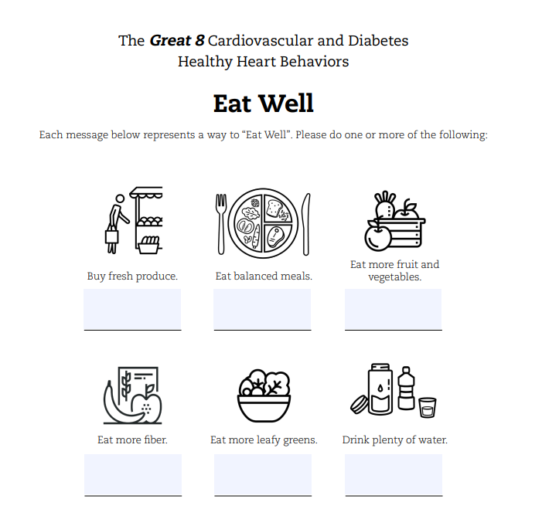
Online resources for Eat Well
Food and Nutrition Handouts in English and Spanish
Nutrition Materials in Chinese, Spanish, and Vietnamese
Healthy Eating Plate – Translations in multiple languages
Office of Women’s Health – Nutrition Information
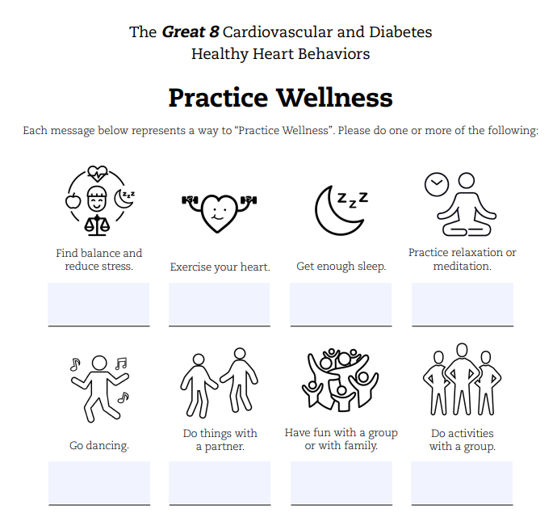
Online resources:
Coping with Stress – multiple languages handout
Free Guided Meditations from UCLA Health in multiple languages
Tips to Care for Yourself – One Small Way Each Day (English)
CDC’s “How Right Now” – online resource for “finding what helps” (English)
Office of Women’s Health Mental Health resources, including stress, sleep (English)
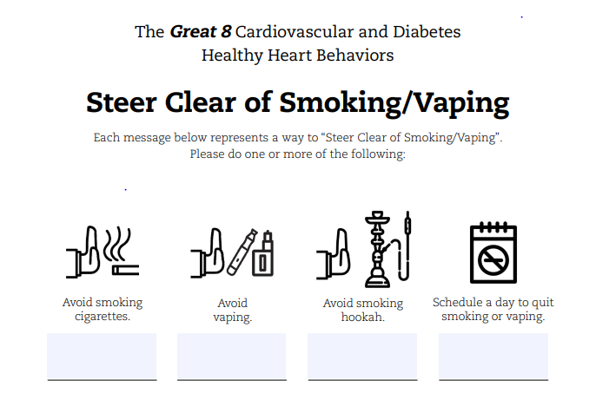
Online Resources:
Washington State Department of Health Tobacco Cessation resources English | Spanish
Tobacco Education Clearinghouse of California – Multiple Language Resources
California Smokers’ Helpline - Vaping and Quitting information in Multiple Languages
King County - Resources for Quitting Smoking, Chewing and Vaping

Health Coaching Resources
Materials on subsequent pages (8-18) adapted from the Missouri WISEWOMAN provider manual 2016-2017. https://health.mo.gov/living/healthcondiseases/chronic/wisewoman/pdf/ProviderManual2016-17.pdf
