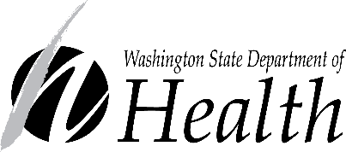
Youth Advisory Council: Invitation to Apply
Example Social Media Posts for Partners

Thank you for helping to spread the word about the Youth Advisory Council! Feel free to tailor these example posts for your audiences. Please publish them before the application deadline of January 31, 2023.
Have questions or feedback? Please contact Adolescent Health Consultant Alexis Bates.
Facebook/Instagram
Get involved and get a $50 gift card! We’re recruiting people ages 13-22 to serve on our Youth Advisory Council. We’re looking for young people from all walks of life with a variety of lived experiences (BIPOC communities, LGBTQIA+, disability experiences, rural communities and more).
Youth Advisory Council members will share their thoughts, opinions, and recommendations about important health topics to help guide public health projects for Washington’s young people. You’ll earn a $50 gift card for each activity you participate in! Learn more and apply by January 31. Find the link in our bio.
https://waportal.org/partners/home/adolescent-health/youth-advisors
Spanish:
Estamos invitando a personas de 13 a 22 años para servir en nuestro Consejo Asesor Juvenil. Estamos buscando jóvenes de todas las profesiones y condiciones sociales con distintas experiencias vividas (comunidades BIPOC (personas negras, indígenas, y de color) LGBTQIA, personas con experiencias de discapacidad, y de comunidades rurales y más).
Los miembros del Consejo Asesor Juvenil compartirán sus pensamientos, opiniones y recomendaciones sobre temas importantes de salud para ayudar a guiar los proyectos de salud pública para los jóvenes de Washington. ¡Ganarán una tarjeta de regalo de $50 por cada actividad en la que participen! Más información: https://waportal.org/partners/home/adolescent-health/youth-advisors (sólo en inglés)

Twitter
We're recruiting people ages 13-22 to be on our Youth Advisory Council. Youth can share their thoughts & opinions to guide public health work! Find more info: https://waportal.org/partners/home/adolescent-health/youth-advisors
We are recruiting people ages 13-22 to share their thoughts on health topics to guide public health work! Learn more & apply: bit.ly/3GUSRwW

Images
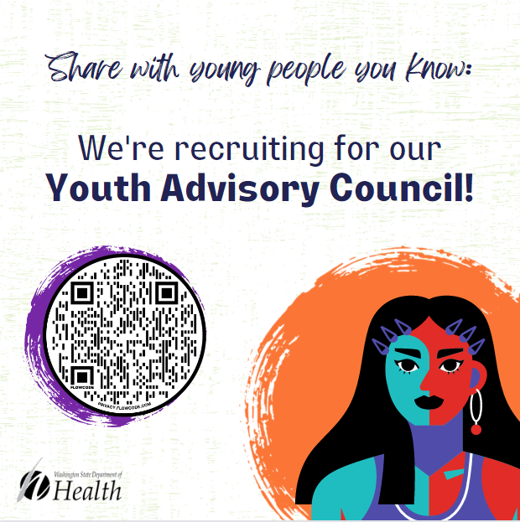  Alt: Text reads: “Share your life experience- apply to be a member of our Youth Advisory Council!” A QR code and an image of a young person are displayed. | 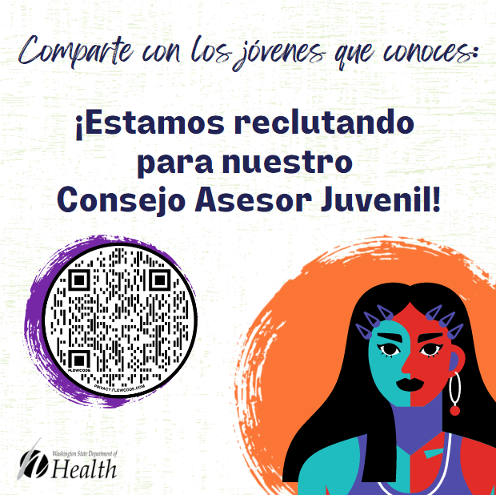  Alt Texto dice: "Comparte con los jóvenes que conoces: ¡Estamos buscando candidatos para nuestro Consejo Asesor Juvenil!" Se muestra un código QR y una imagen de un joven.
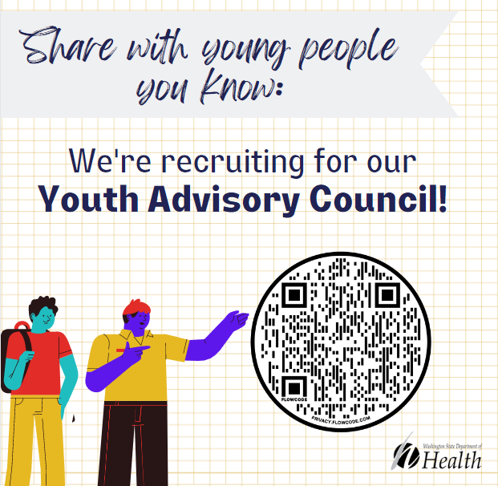  Alt text: Share with young people you know: We’re recruiting for our Youth Advisory Council!” A QR code and an image of two young people are displayed. | 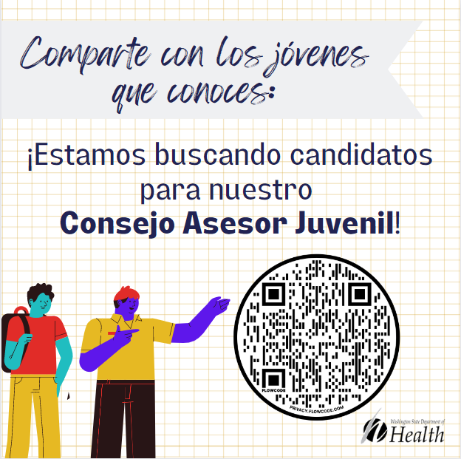  Alt text: Comparte con los jóvenes que conoces: ¡Estamos buscando candidatos para nuestro Consejo Asesor Juvenil!" Se muestra un código QR y una imagen de jóvenes.

To request this document and/or the images in another format, call 1-800-525-0127. Deaf or hard of hearing customers, please call 711 (Washington Relay) or email civil.rights@doh.wa.gov.

