Colorectal Cancer Task Force Kick-off Meeting Notes
Date: 03/03/2023
Time: 9:00 am- 10:00 am PST
Time | Activity | Facilitator
9:00  am | Introduction & Welcome  - Attendees’ name & org  - Kayla Kenyon, Fred Hutch  - Mary Miller, Comm health educator- Fred Hutch  - Katie Treend, Dept. of Health  - Sahla Suman, Dept. of Health  - Char Raunio, American Cancer Society  - Daniel Padron, Fred Hutch  - Katherine Stang, Peninsula Community Health Services  - Donna Oliver, Dept. of Health BCCP  - Jodi Olson, Public Health Seattle and King County  - Eudora, Center for multicultural health-  - Kess Walp, Island Help- first time- listen and learn.  - Kathy Briant, Fred Hutch  - Geoff Jones, New Port WA, Eastern WA University, University of Washington  - Casey Eastman- Dept. of Health  - Kim Wilson, Better health together ACH  - Bev Green- Kaiser Permanente  - Tammy- House of charity- Spokane  - Ari Bell Brown, Fred Hutch  - Amanda Kimura, Fred Hutch  - Gwen Weber, DOH- CRC screening team  - Beth Bristol, Patient outreach- Virginia Mason  - Shalene Nelson, Confluence Health.  - Kim Ward from Providence Inland NW  - Jennifer Johnson-Joefield, Peninsula Community Health Services  - Kim Fischer- Oncology Quality Coordinator at Confluence Health  - Nini Shridhar- State Genetics Coordinator  - Edgar Lopez-Baez, CHW Specialist, Foundation for Healthy Generations  - Alicyn Elder, Community Relations with Coordinated Care serving the greater Spokane area.  - Craig Dee (Diné) project manager for the Indigenous Cancer Health Equity- Office of Community Outreach & Engagement at Fred Hutch.  - Dave Iverson, CEO Healthy Ferry County Coalition | Kayla Kenyon
9:15 am | History & Context of CRC Task Force  - Since 2016  - Aligned with National CRC roundtable.  - Previous campaign  - 80% by 2018  - Didn’t meet the goal due to various reasons- pandemic.  - Now- 80% in every community  - Past meetings:  - In- person training, technical assistance  - Coordinated Media/ Communication campaign.  - Why this taskforce  - Taskforces provide:  - Education, training, latest research, data, resources and materials, networking with peers  - Coordinate efforts to overcome challenges and accomplish goals together.  - Examples of what we can do today:  - March- CRC Awareness month- spread the message.  - Resources to use toolkits from GWU | Katie Treend
9:25 am | Brainstorm and Discussion  Link to the Jamboard | Mary Miller
Brainstorm Notes

Katie’s breakout session notes
- What do you want to see happen in this space?
  - Edgar- collaborate work, community work.
  - Kim- Having a toolkit will be awesome, agree with Edgar- developing a care pathway- require a lot of communication- to get the patient from point a to b, multiple barriers along the way, need coordinators to work with the follow up care- multiple touch points, not just one!
  - Kess Walp- like to see examples of screening program, especially for rural communities, have a backlog of colonoscopies- ppl are not getting screening, because we don’t have screening test – help community avoid unnecessary colonoscopies if they can get screening- in Anacortes.
  - Dave- Rural areas have more barriers.
  - Kim- Giant colon model helps create a lot of awareness.
- What are the barriers to screening?
  - Edgar- barriers are different for different people, at Sea Mar- don’t have follow up system, financial barriers- restrict follow up to get the colonoscopy, how can we support the community with this?
  - Kess- for organization- money and resources- where to find the grants for this purpose?
- What do you want to see happen in your own communities?
  - Point person to communicate with primary care or follow up care. Reaching all the touch points.

Daniel’s breakout session notes
- Geoff Jones:
  - Increased access to cancer screenings
  - Place for decent bowel prep (keeping dignity intact)
- Casey Eastman:
- Access/High quality decision making between patient/physician.
- There is less funding from CDC for screenings. Finding ways to leverage money for screenings.
- Ari Bell*:
  - Identify dollars for uninsured/underinsured populations.
  - Create coordinated care (from first contact with physician, to referral, through screening, and follow-up) continuum of care.
  - Lyft Pilot Program (HIPPA compliant)
    - Contract between Harborview/Lyft for screening transportation
    - Pilot has been going for about a year.
    - Allows riders with moderate sedation.
- Cindee:
  - Useful Resources/Materials for our communities (outside of English)

Kayla’s breakout session notes
- What do you want to see happen in this space?
- Barriers to screening
- What do you want to see happen in your communities?

- Ryan-ACS
  - Prevention and quality of care improvement for CRC. Particular focus on provider education, either in the form on creating better content to support provider understanding or in doing better outreach in midst of workforce issues in hospitals and burnout among providers and hospital staff.
- Donna-DOH
  - Addressing underserved and additional barriers to screening. Enhancing systems in communities and relying on local resources and organizations for navigation and educational training. Community and clinical services connection is a priority.
- Nini-DOH
  - Education on hereditary cancers for better understanding in communities, but in particular surrounding Lynch syndrome for CRC outcomes. Family history and outreach to discuss the risks associated with genetic factors.
- Amanda-FH
  - Follow-up in colonoscopy process. Mailed FIT kit program great for getting people screened but needs better follow up to connect patients who test positive with resources for treatment. Different connections to reach more populations. Data linkages for better health systems connection with services and data
- Gwen-DOH
  - messaging surrounding FIT kits and how it guides people to getting a colonoscopy. Expanded outreach and support for more navigation of systems. Sometimes patients don't know what they are supposed to do when they receive information.
- Jodi-DOH
  - low-income populations in particular undocumented sometimes don't have access to Medicaid and project access can be cumbersome to navigate and get a pro bono colonoscopy. Navigation of systems and interoperability are priorities.
- Who needs to be invited to the table? ---> gastroenterologists to provide more of a clinical perspective will be important going forward.
Whole Group Discussion
- Kayla’s group discussion/share out.
  - Themes- access to CRC care and screening, education and navigation of the process- provider and patient education, education about CRC cancer, hereditary cancers, who is not at the table today, this is an open group- be inclusive and we need everyone at the table.

- Daniel’s group discussion/ share out 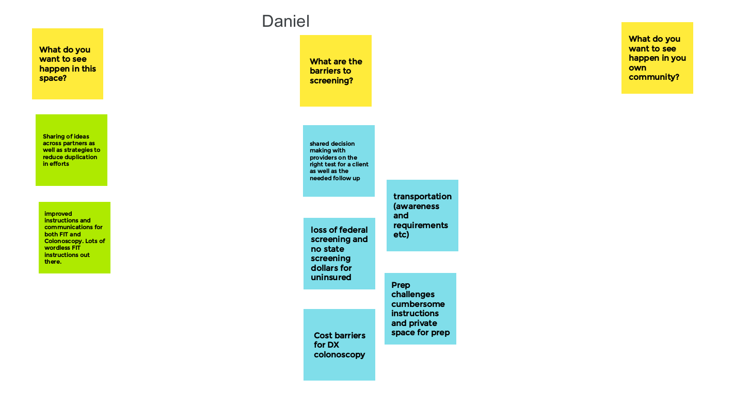
  - Transportation, awareness, navigating through the process, system.
  - What we want to see:
    - strategies sharing, how can we supplement each other to meet the goal, improve structure and communication around FIT and tests.
  - Barriers:
    - shared decision making, follow up- not knowing what the result meaning, cost, prep for the test, continuing care from start to finish and follow up.
  - Solution to the barriers were discussed- the pilot program.

- Katie’s group discussion/ share out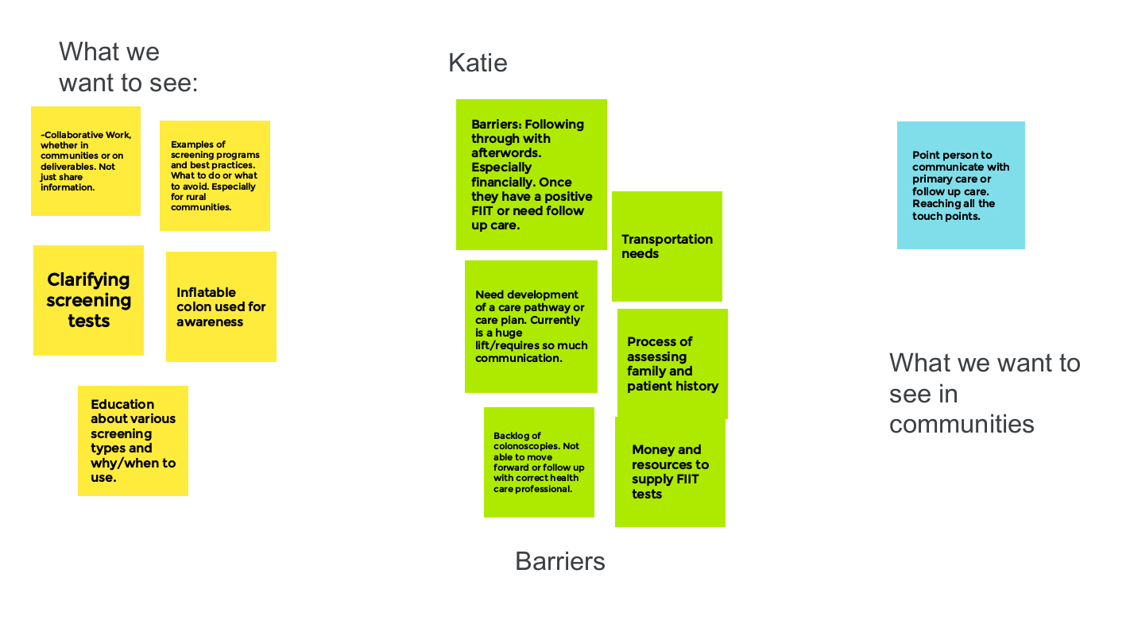
  - Want to see:
    - Collaborative work, working with the communities.
    - Types of tests, acronyms of test, examples of successful screening programs, tests
    - More educational events
  - Barriers:
    - Not having follow through, especially finance, transportation in rural areas.
    - For organizations- accessing kit and resources.
  - Want to see in the community:
    - Care coordinators to work with the follow up care- reaching all touch points.

- Char’s group discussion/ share out.
  - Want to see in the Task force:
    - Collaboration and learning, data sharing, education, strategies that increase screening rate, eliminate barriers- understanding payment, research, education.
  - Barriers:
    - Lack of knowledge of payment- insured or not, covered or not
    - Lack of funding
    - Cancer rates increasing
  - Future- looking the report- talk to the leadership
9:45 am | Next Steps  - Next meeting is on: June 23rd, 2023.  - Mary and Kayla will send the link and invitation to the meeting.  - Quarterly meetings  - Happening now:  - Communication for CRC awareness month  - Expand partnership.  - Future:  - Formalized shared mission and vision.  - Identify and reach out to people who are not at the table today and we want to include everyone.  - Contact info:  - Katie Treend, DOH  - Katie.Treend@doh.wa.gov  - 360-236-3674  - Mary Miller, OCOE  - MMiller2@fredhutch.org  - 509-280-3863 | Katie Treend

