Onboarding your group onto WA Portal’s team space

**Introduce the website via email**

Briefly tell your members about WA Portal. Share a customized message to:

* Recap the group’s goals and objectives.
* Explain what they will gain from using WA Portal, describing what will be provided in the team space.
* Give any Do’s and Don’ts about using the team space, for example ask that they not delete files or folders visible in the space or share certain documents outside of the group.

**Text you’re free to copy, customize, and send to members:**

Hello,

The ---[insert name of group or program using WA Portal]--- will be using the Healthier Washington Collaboration Portal (www.WAPortal.org) to strengthen our ability to connect on this project. This will be a space where we can place useful links and documents for you to access. It also includes a discussion board for members to read and post comments.

**Tip:** You can use the image below but it’s better to share a screenshot of *your* team space in your message.

Beginning ---[provide a date or date range]--- we will send you an invitation to create an account on the site. You will receive automated messages from WA Portal (Healthier Washington Collaboration Portal waportal@doh.wa.gov) with a direct link with instructions to easily create an account.

Here is a preview of our team space:

Here is what the automated email says (it will show your email address, not Victor’s):

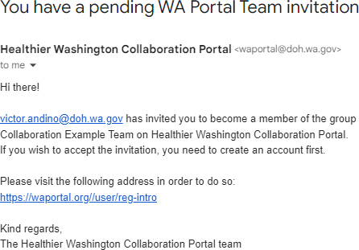

After your member follows the link and completes the registration form, they see this screen when they click on My Portal:

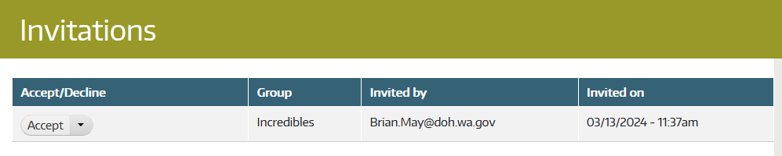

They must click on **Accept** to finish the process. If they click on the team’s name, they will only be able to see the top portion of the team’s dashboard.

Problem-solving

* *An invited team member can’t see the folders in your team.*

The person didn’t click “accept” on their My Portal team. Advise them to do so when they log in or

Go to your **Members** tab.



Then click **Add a member.**

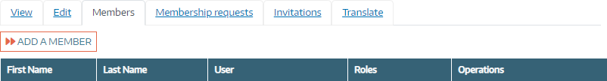

Insert the member’s email address.

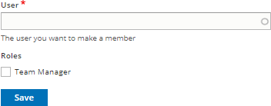

As long as the person has a WA Portal account, you can add them to the team. This will not work if the person didn’t respond to the invitation email and complete their registration.

* *Member is unable to get past the log in screen.*

Common occurrences:

* + The member may have clicked the link in the email that gave them one-time access to create the password but didn’t complete the process.
  + The member, or their browser’s password tool, may be inserting a different email address or password than what they used the first time they registered.

Solutions:

* + The member can try the Reset Your Password screen
  + Reach out to the WA Portal Support team
* *Member is logged in but unable to see your team*

Go to the Members tab and use the Add a Member process.

* *Members are not coming to the Portal*

Use strategic timing to resend your onboarding message, such as two to three days before a meeting with the members. Communicate about a deadline that is approaching and emphasize the material they will need to access in the team space.