We are thrilled to report the outstanding success of our "Juntos por tu Salud" (Together for Your Health) event, a collaborative effort that brought together multiple organizations to promote community health and well-being. The event, which took place over three days from December 13-15, 2024, exceeded our expectations in terms of attendance and impact.
Event Overview
The event was a joint initiative by:
BMAC, represented by Itzel Cueva Guerra (Farmworker Engagement Coordinator Community Education & Engagement)
WWIRC, represented by Paola Herrera Silva (Community Engagement Coordinator & Health Promoter)
Adventist Church, represented by Pastor Rodriguez (who agreed to refrain from proselytizing during the event)
Greater Health Now, Maria Remington
Day-by-Day Highlights
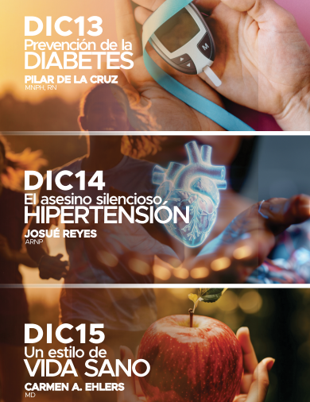
Day 1 (December 13, 2024)
Topic: Diabetes Prevention
Presenter: Pilar De La Cruz Registered Nurse and Professor from the University of Washington
Attendance: 14 via Zoom, 35 adults in-person, 12 children
Mini Resource Fair: Walla Walla Community College (offering ESL classes), BMAC (providing energy assistance and rent payment assistance)
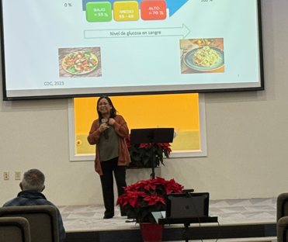

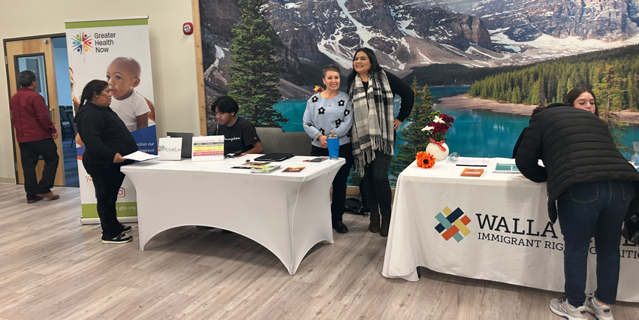

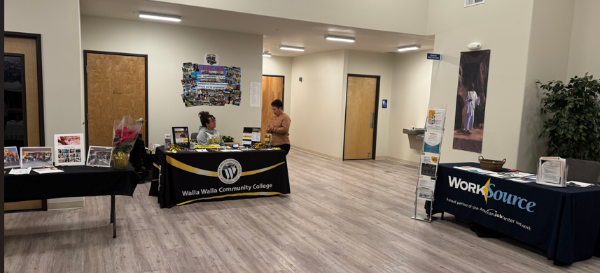

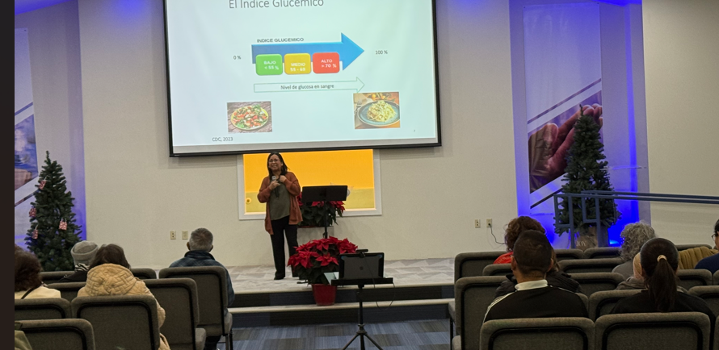
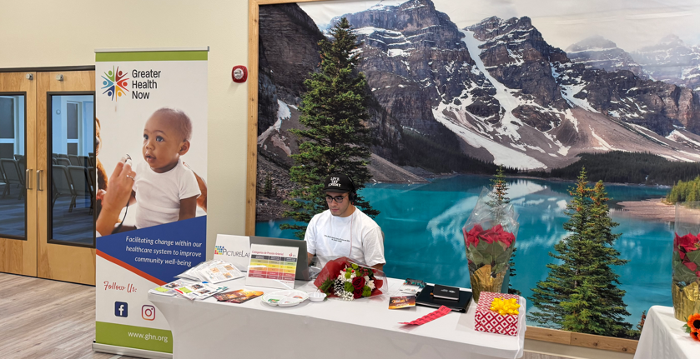

Day 2 (December 14, 2024)
Topic: The Silent Killer - Hypertension
Presenter: Josue Reyes, ARNP and founder of Mobile Care in Walla Walla
Attendance: 18 via Zoom, 60 adults in-person, 15 children
Additional Services: Blood pressure checks by Registered Nurse Pilar De La Cruz, distribution of 4 BP monitors to those in need

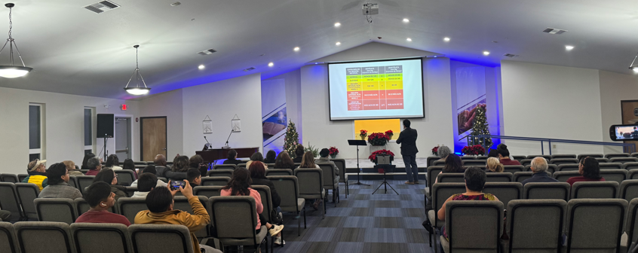
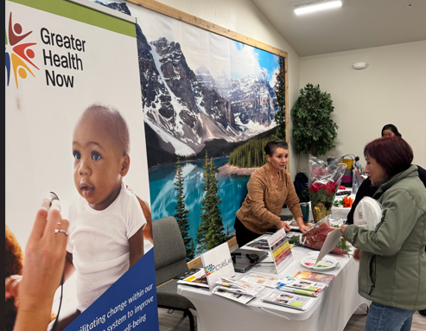

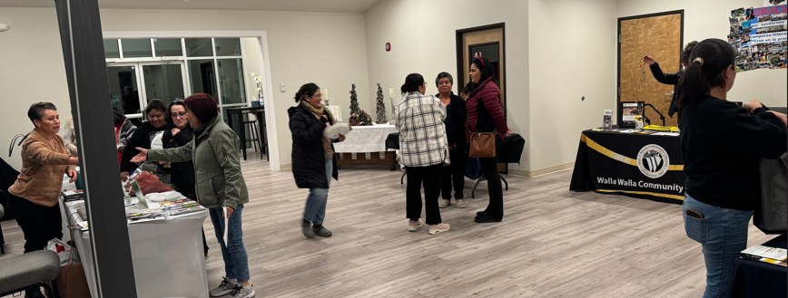

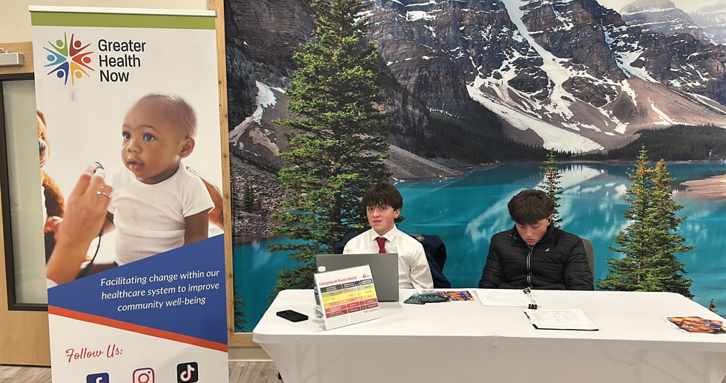
[Grab your reader’s attention with a great quote from the document or use this space to emphasize a key point. To place this text box anywhere on the page, just drag it.]
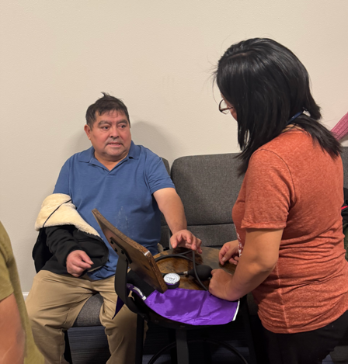
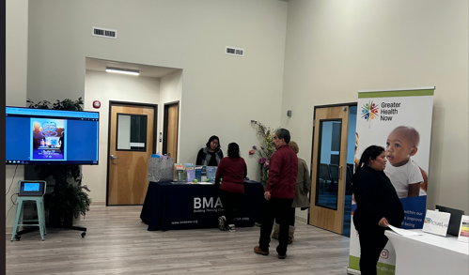
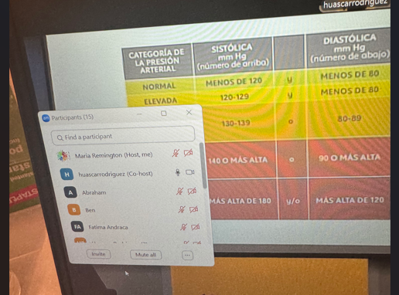

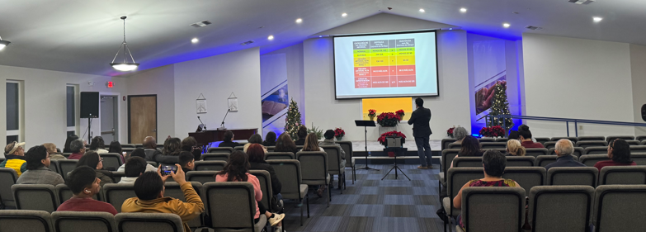

Day 3 (December 15, 2024)
Topic: A Healthy Lifestyle
Presenter: Dr. Carmen Ehlers
Attendance: 18 via Zoom, 25 adults in-person, 6 children
Additional Services: Blood pressure checks by Registered Nurse Pilar De La Cruz, distribution of 6 BP monitors to those in need.
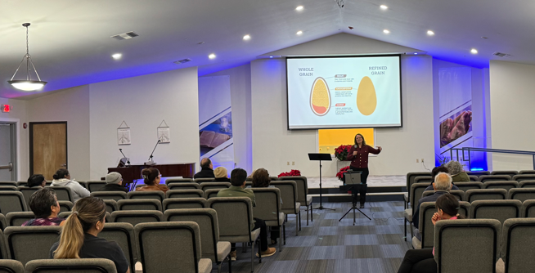
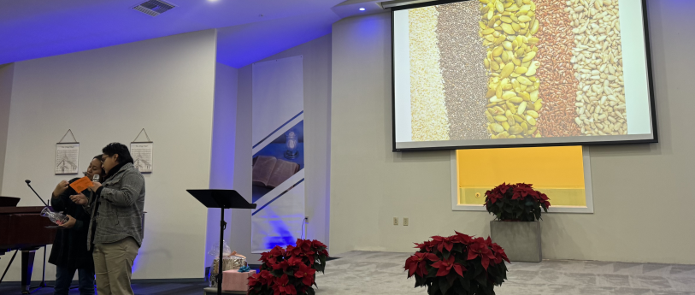
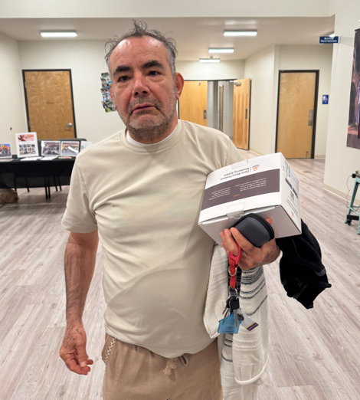

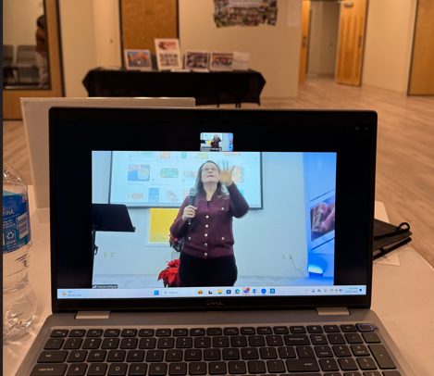

Community Involvement
Throughout the event, we had invaluable support from:
Mujeres en Acción del Valle de Walla Walla volunteers
Walla Walla High School 4 students
A student from Walla Walla University
Promotion and Outreach
The event was promoted through:
Flyers distributed by all four organizing entities
Website postings
Direct invitations at two community fairs
Personal invitations from Pastor Rodriguez to church members
Outreach to College Place public schools
Incentives and Resources for the attendees
24 raffle prizes (8 per day) donated by various community partners
10 free BP monitors distributed to individuals with high blood pressure
30 portion plates
The "Juntos por tu Salud" (Together for Your Health) event exemplified the power of education and prevention in community health initiatives. This successful program, part of the 2109 grant project, was made possible through the collaborative efforts of multiple organizations working towards a common goal.
The event highlighted one of the key pillars of the promotora framework: education and prevention through the health workshops. By implementing this pillar, promotoras were able to effectively engage with the community and gain valuable insights into the specific health needs of their respective counties. The workshop topics were carefully selected based on the requirements expressed by community members, ensuring relevance and impact.
This collective effort demonstrated the importance of providing accessible health education and resources. The hybrid format of the event allowed participants to join from the comfort of their homes, though there is still work to be done in expanding reach to ensure all community members can benefit from these valuable workshops.

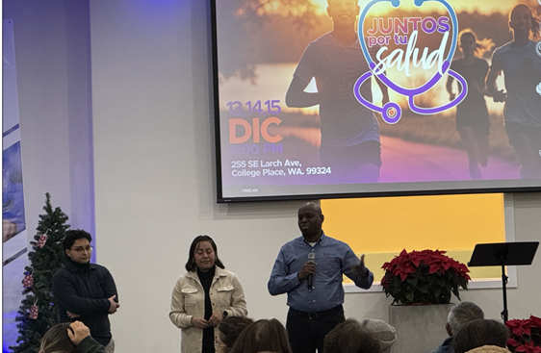
The role of promotoras in utilizing one of the pillars of the framework of promotoras Education and prevention through health workshops was crucial in:
Providing access to resources and education
Promoting early disease prevention through awareness
Encouraging community members to seek expert help
Facilitating connections between participants and health professionals
Additionally, these events served as opportunities for promotoras to identify potential clients for referral to the Hub or other agencies, further extending the impact of the program.
By focusing on education and prevention, "Juntos por tu Salud" has taken a significant step towards improving community health outcomes and empowering individuals to take control of their well-being.

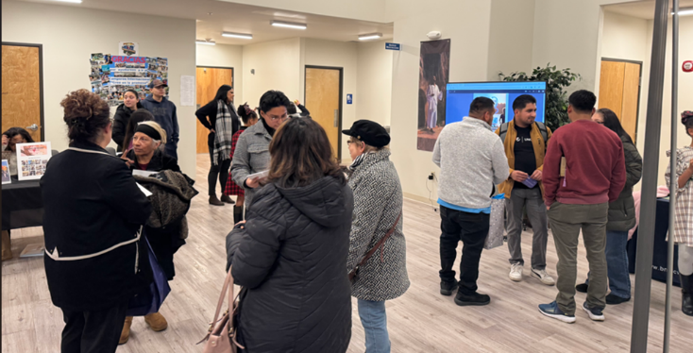
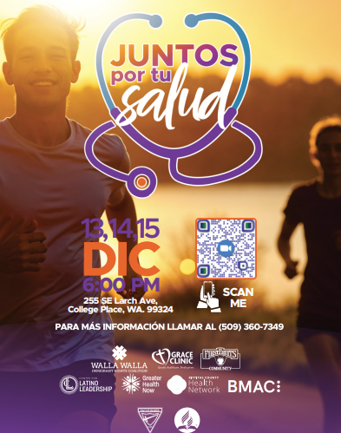

By,
