**Situation:**

Washington is the second-largest wine-producing state in the US, contributing more than $8 billion in annual in-state economic impact. An American Viticultural Area, or AVA, is a specific type of appellation of a grape-growing region with specific geographic or climatic features that distinguish it from the surrounding areas and affect how grapes are grown. Most of the 20 American Viticultural Areas in Washington State are in the **South Central Region.**

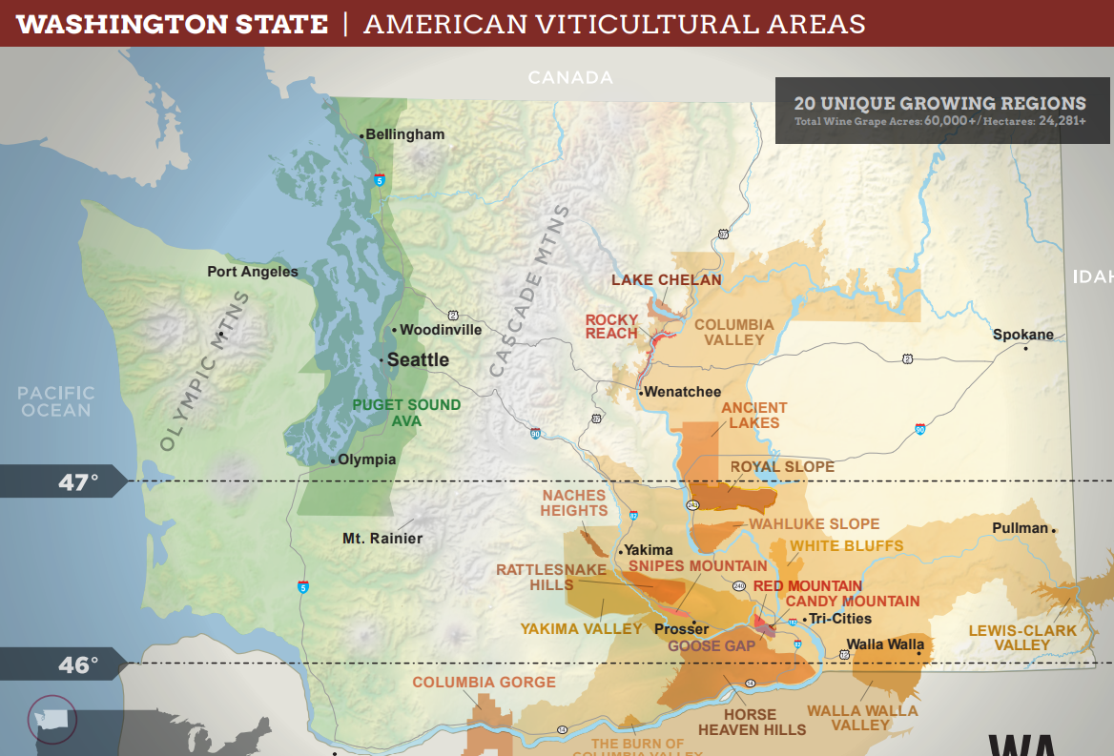

**Background:**

In September 2021, Providence Population Health, a Care Connect WA Hub at the time, partnered with Vital Wines to hire Walla Walla Valley’s first **Promotora de Salud**. Vital Wines is a Walla Walla non-profit, committed to improving equity and access to healthcare for vineyard workers and their families. Their mission aligns with key health equity initiatives, particularly lessons learned from COVID-19 and the disproportionate impact on BIPOC communities. In the South-Central regions, LatinX populations working in agriculture were the most impacted.

The Vital Promotora created a framework describing a five-pillar approach to reaching and impacting priority populations. Each component is interlinked and an integral part of building trust.

The five-pillar framework is rooted in the foundations of:

* **Outreach**
* **Advocacy**
* **Events (Resource Fairs)**
* **Workshops**
* **Individual Navigation**

This framework has positively impacted the LatinX community working in agriculture in the Walla Walla Valley. Meeting the workforce in the vineyards, navigating to a medical home, getting overdue preventive screenings, COVID testing and vaccinations, addressing the cultural stigma of mental illness, or reaching thousands of individuals at popular resource fairs and workshops conducted in Spanish, **the five-pillar approach is working.**

In February 2023, Greater Health Now was encouraged to apply for a Congressional Directed Spending request to address the Maternity Care Desert in the Lower Yakima Valley. (See White Paper)The Lower Yakima Valley is home to the Yakama Nation (47%) and unserved Hispanic communities (23%). Living in a maternity care desert is particularly problematic for women who lack prenatal care or are considered high-risk. Because of stark health disparities, racial and ethnic minority populations are at inherently high risk. The lack of medical professionals in this maternity dessert also means that the next generation of medical professionals is not being afforded the opportunity to learn culturally appropriate caregiving, thus perpetuating the cycle and ensuring that these underserved populations remain at risk. *The Institute for Medicaid Innovation reported in 2020 that community-based maternal support, such as doulas, Promotoras, and community health workers in Medicaid populations, consistently results in positive health outcomes for mothers and newborns while reducing costs*.

**Assessment:**

Greater Health Now is looking to expand the Walla Walla Promotora model throughout the South-Central Region. As the ACH and a Car Connect Community Hub, Greater Health Now is aligning cross-sector collaborations and integrated partnerships to replicate the success of the Walla Walla flagship program while recognizing each region has its distinct flavor.

Standardization goals:

* **Define program logistics**
* **Employment structure**
* **Blueprint for services**
* **Criteria for data collection and evaluation**

**Recommendation:**

**Hire Promotoras to cover/represent the prominent AVA areas in the South-Central Region**. Over the next year, these contracted positions will be the liaison between the CDC’s priority populations and the Hub. Findings (*Encuesta “*survey”, community voice, data collection) will influence Hub and ACH infrastructure to advance health equity and whole-person health. The AVA Promotoras will also seek natural partnerships (community-based organizations, grape and orchard growers) to expand the program based on need, i.e., mobile health, telehealth, chronic disease support, maternal child health, vision, dental, etc. A **Manager of Equity and Collective Impact**, employed by Greater Health Now, will provide program oversight and support the team of Promotoras. The **Mobile** **Program Coordinator** will assist with coordinating events, scheduling with WSU/Range health, and communication between the team and the CBO employers. The Hub will provide resources, technical assistance, data management, and fidelity oversight. The Hub will also seek funding opportunities (grants, philanthropy) for growth and sustainability. Based on financial modeling in Walla Walla, the program has multi-sector grant and donor appeal (health equity, wine industry, commerce, workforce, research, fellowships, health, and wellness). The DOH will assist with the program evaluation. Health Partners, the North Central CCWA Hub, will provide technical assistance via evidence-based chronic disease self-management education (CDSME).

**Washington State AVA Region**

(Highlighted cells indicate grape growing region in the South-Central Region)

|  |  |
| --- | --- |
| **Candy Mountain** | * Benton |
| **Goose Gap** | * Benton |
| **9Horse Heaven Hills** | * Benton * Klickitat * Yakima |
| **Naches Heights** | * Yakima |
| **Rattlesnake Hills** | * Yakima |
| **Red Mountain** | * Benton |
| **Snipes Mountain** | * Yakima |
| **Walla Walla Valley** | * Walla Walla |
| **White Bluffs** | * Franklin |
| **Yakima Valley** | * Benton * Yakima |