WASHINGTON STATE DEPARTMENT OF HEALTH
Diabetes Awareness 2025
Communications Toolkit

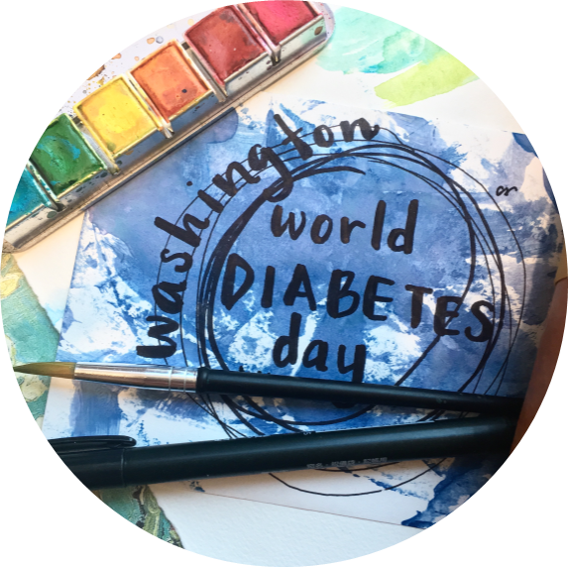

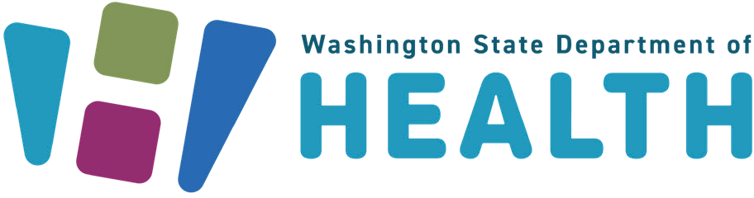

To request this document in another format, call 1-800-525-0127. Deaf or hard of hearing customers, please call 711 (Washington Relay) or email doh.information@doh.wa.gov.

Background
November is National Diabetes Month — and World Diabetes Day (WDD) on Nov. 14 — brings communities across the United States and globally together to:
- Increase awareness and educate employers and employees about the impact of diabetes in the workplace
- Inform employees on the importance of screening and early detection
- Encourage nutrition, mental well-being support, and physical activity for the benefit of your workplace.
There are almost 600,000 adults with diabetes, and as many as 2 million may have prediabetes in Washington. Diabetes is the seventh leading cause of death in our state. We invite you to join us in participating in the World Diabetes Day Washington 2025 social media campaign.
The campaign draws attention to important issues in the diabetes world and keeps diabetes firmly in the public spotlight. Washington’s theme this year follows the International Diabetes Federation’s worldwide campaign, “Know more and do more for diabetes at work.” For more information on the international World Diabetes Day campaign, please visit worlddiabetesday.org. This social media toolkit was created to complement any awareness efforts your organization may already be doing.
This campaign includes three primary key message categories:
- Diabetes awareness
- Diabetes screening
- Management in the workplace
We encourage organizations to post messages from each category in November. Posts could be sent out daily or a few times a week and can be used multiple times throughout the campaign. Early posts and messaging can be used to raise awareness of the annual World Diabetes Day on Nov. 14. Each message category includes optional hashtags that can be used for the campaign. Social media posts have the capacity to include many hashtags, but we encourage partners to include #WDDWashington to support this campaign. We have included a sample schedule that uses the included campaign messages and sample posts.

Sample Schedule

Nov. 3-9 | 3 posts on 3 separate days with at least one featuring diabetes awareness in the workplace on the first week of November.
Nov. 10-16 | 3 posts on 3 separate days. On November 14th, use Category 1 Message 5, or another of your choosing, to commemorate World Diabetes Day.  Encourage those in your organization to wear blue on Nov. 14 and ask employees to take pictures and post them to your organization's social media. It’s a fun way to show your support!
Nov.17-23 | Share/promote three posts on 3 separate days. Posts on the third week of November should feature diabetes screening.
Nov. 24-30 | 3 posts on 3 separate days, one from the diabetes management category. On November 30th utilize Category 1 Message 4, or your own, to thank community members for supporting the WDDWashington campaign.

Key Messages

Category 1: Diabetes Awareness
From establishing workplace policies to listening and providing support, employers can do a lot to create inclusive and friendly workplaces for people with diabetes. Learn how: https://www.cdc.gov/diabetes/hcp/employers
#WDDWashington

Globally, 7 in 10 adults living with diabetes are of working age. In the workplace, diabetes can become a source of stress, stigma, and fear. Learn more: https://worlddiabetesday.org/ #WDDWashington
Around 88 million adults have prediabetes, that is one in 3 adults. Are you one of them? See if you are at risk: https://doihaveprediabetes.org/take-the-risk-test#/
#WDDWashington
Thanks for supporting #WDDWashington. To find diabetes resources near you, call 211 or visit the website https://wa211.org/
#WDDWashington

We stand together to fight diabetes! Learn about World Diabetes Day and check out their website, https://worlddiabetesday.org, and share how you support people with diabetes.
#WDDWashington

Category 2: Diabetes Screening
Encourage regular diabetes screening as part of your company’s wellness program. A simple test today could prevent serious complications tomorrow. https://www.cdc.gov/diabetes-prevention/employers-insurers/type-2-diabetes-resources.html
#WDDWashington

This World Diabetes Day, take 5 minutes to get screened and encourage your coworkers to do the same. Learn more about diabetes and the workforce: https://www.cdc.gov/diabetes-prevention/employers-insurers/index.html
#WDDWashington

Check out the CDC’s Work@Health Employer Training Curriculum — a free, science-based training program to help employers of all sizes create or improve worksite health programs.
https://www.cdc.gov/workplace-health-promotion/php/training/employer-training.html
#WDDWashington

Did you know that employers can use tools like the CDC Worksite Health ScoreCard to evaluate and strengthen their wellness programs — including steps to promote early detection of diabetes? https://www.cdc.gov/workplace-health-promotion/php/scorecard/index.html
#WDDWashington

With CDC’s prediabetes risk test, it takes just 60 seconds to find out if you are at risk for type 2 diabetes. Take the test and urge your coworkers to take action. https://www.cdc.gov/prediabetes/risktest/index.html
#WDDWashington

Category 3: Diabetes Management
3 in 4 people living with diabetes have experienced anxiety, depression, or another mental health condition because of their diabetes. Get mental health resources: https://diabetes.org/health-wellness/mental-health
#WDDWashington

Moving your body can help you feel better, work better, and support your diabetes care. CDC has a few ways to move your body at work: https://www.cdc.gov/physical-activity/php/strategies/access-to-places.html
#WDDWashington

Are you looking for advice on adding more nutrients to your diet? Check out the suggestions offered by CDC: https://www.cdc.gov/diabetes/healthy-eating/?CDC_AAref_Val=https://www.cdc.gov/diabetes/managing/eat-well.html
#WDDWashington

Being active and eating a more diverse diet can help manage diabetes and prevent Type2DM. What’s one change you can make for #WDDWashington? Check out these tips from NIH: www.niddk.nih.gov/health-information/weight-management/tips-get-active/tips-starting-physical-activity
#WDDWashington

Digital Media Photo Library

Choose from the photos below to match your social media message.

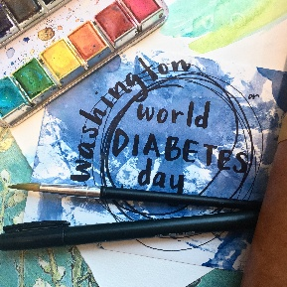  HDSDP World Diabetes Day Logo Washington.jpg (3024×3024) | 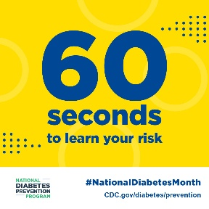  HDSDP 60Seconds.jpg (1080×1080) | 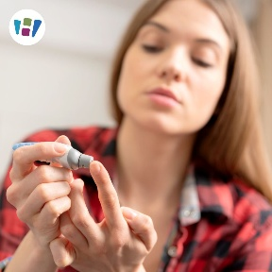  HDSDP Blood sugar testing young woman.jpg (1080×1080)
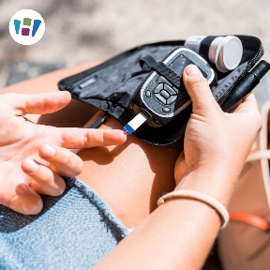  HDSDP blood sugar monitoring.jpg (1080×1080) | 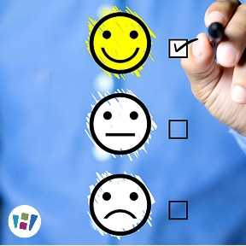  HDSDP Checklist (1).jpg (1080×1080) |   HDSDP family walking with dog.jpg (1080×1080)
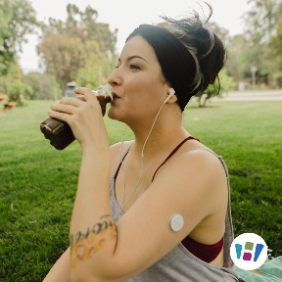  HDSDP glucose monitor.jpg (1080×1080) | 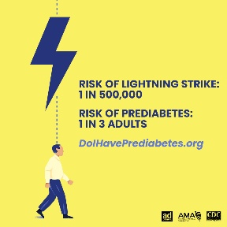  HDSDP lightning strike.jpg (1024×1024) | 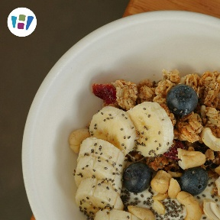  HDSDP oatmeal breakfast.jpg (1080×1080)
  HDSDP Office.jpg (1080×1080) |   HDSDP Older adult couple walking.jpg (1080×1080) |   HDSDP Apples.jpg (1080×1080)
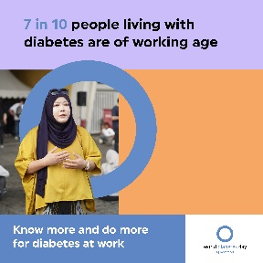  HDSDP social media 14.jpg (4500×4500) |   HDSDP Thanksgiving Dinner (1).jpg (1080×1080) | 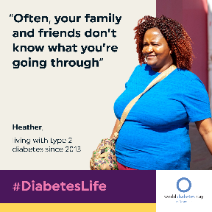  HDSDP WDD_Heather-1.png (2001×2001)
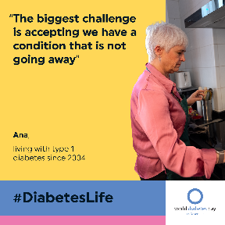  HDSDP WDD_QuoteCard_1.png (2001×2001) | 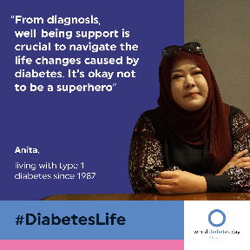  HDSDP WDD_QuoteCard_-1.png (2001×2001) | 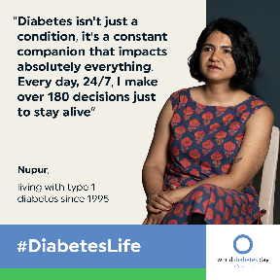  HDSDP WDD_QuoteCard_India_-1.png (2001×2001)
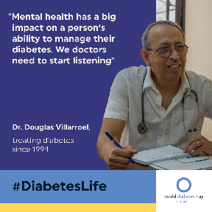  HDSDP WDD_QuoteCard-1.png (2001×2001) | 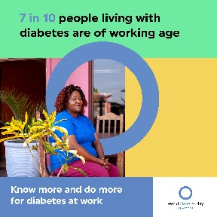  HDSDP WDD-social-media7.jpg (4500×4500) | 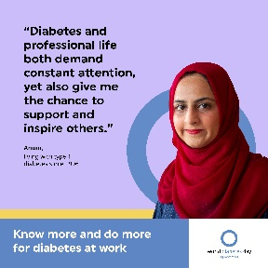  HDSDP WDD-social-media13.jpg (4500×4500)

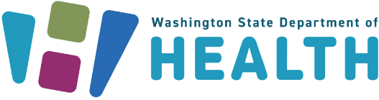
To request this document in another format, call 1-800-525-0127. Deaf or hard of hearing customers,
please call 711 (Washington Relay) or email doh.information@doh.wa.gov

