WASHINGTON STATE DEPARTMENT OF HEALTH
American Heart Month Tool Kit
February 2026

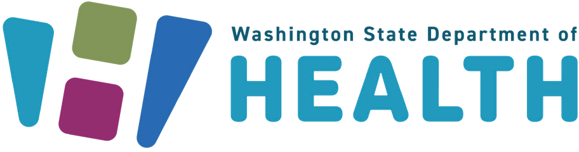

To request this document in another format, call 1-800-525-0127. Deaf or hard of hearing customers,
please call 711 (Washington Relay) or email doh.information@doh.wa.gov.

Table of Contents

Background 3
Talking Points 3
All Audiences 3
For Health Care Team Members, Including Community Health Workers 4
Social Media Posts 5
Written Content 9
Wear Red Day is Here! 10
Use Building Lights to Show Your Support for Wear Red Day 10
Downloadable and Orderable Digital Resources 11
Heart Attack and Stroke and Blood Pressure Management – Multiple Languages 11
Great 8 – Multiple Languages 11
Washington Resources 12
Cardiovascular Connection 12
2-1-1 12
Training for Community Health Workers 12
EthnoMed 12
National Resources 12
American Heart Association 12
Resources in Multiple Languages 12
News and Articles from AHA 13
Centers for Disease Control and Prevention 13
National Heart, Lung, and Blood Institute 13
American Diabetes Association 13

Background
This year, we are encouraging people to “Lead with Your Healthy Heart.” Talking with our loved ones, friends, family, employers, and faith communities about heart health is a great way to get support, set goals, and take care of each other.
February 6 is National Wear Red Day to celebrate the first Friday of American Heart Month. The goal is to raise awareness of women’s heart and brain health and inspire preventative action.
This document includes tools to help providers and partners:
- Communicate changes to the guidelines around high blood pressure. Here is a summary for the general public and health care providers.
- Communicate the risks high blood pressure poses to people’s health.
  - Encourage knowing your numbers
    - blood pressure
    - cholesterol
    - blood sugar
    - kidney function
- Amplify national messages that promote heart health.
- Discover the latest American Heart Association evidence-based recommendations for CPR and ECC.

Talking Points

All Audiences
- February is American Heart Month, and Friday, Feb. 6, 2026, is National Wear Red Day. American Heart Month and National Wear Red Day remind us to take action to protect our heart health.
- Know your blood pressure numbers and what they mean. Having high blood pressure is often the most common predictor of heart issues. Talk to your health care provider to:
  - Get your blood pressure checked
  - Discuss a goal that's right for you - for most adults, this will be under 130/80 mm hg
  - Check your pressure at home
- Work with your loved ones to care for each other’s hearts. You could:
  - support quitting tobacco/vaping
  - offer to help cook heart-healthy meals
  - walk together
  - watch children to provide time for self-care
  - Serve healthy food and beverages at events
- If you have questions about your heart health, talk to a doctor or a health care provider.
- Your health care provider may recommend blood tests to help understand what is happening in your heart and blood. After the results come back, they may make a plan to improve your heart’s health or lower your future risk.
- Community Health Workers, Community Health Representatives, and Promotoras can support you in making lifestyle changes to lower your risk of heart attack and stroke.
- All adults, especially those with a history of heart disease, stroke, or diabetes, are urged to check their immunization status and stay up to date on vaccines, particularly for flu and COVID-19.
- Learn the new 2025 American Heart Association CPR and Emergency Care guidelines. Knowing how to respond to cardiac arrest (heart attack, choking, and overdose emergencies) can help save a life.
- Did you know that taking care of your teeth, mouth, and gums can help lower your risk of heart disease and stroke? Need help finding affordable dental care? Your local Community Health Center can help!

For Health Care Team Members, Including Community Health Workers
There are 8 simple things people can do to lower their risk of cardiovascular disease. The “Great 8” healthy heart behaviors are:
- Be Active
- Eat Well
- Practice Wellness
- Check Your Blood Pressure
- Understand Your Blood Sugar Numbers
- Know Your Cholesterol Levels
- Avoid Smoking, Vaping, and Alcohol
- Follow Your Doctor’s Recommendations
You can access Great 8 materials for free in English, Spanish, and 35 other languages spoken in Washington.

Social Media Posts
In addition to the suggested social media posts below, we encourage you to check out DOH social media channels for blogs and other posts that will come out during the month. Consider adding these hashtags to your social media posts: #WearRedDay #GoRedWA #HeartMonth #AmericanHeartMonth
Looking for photos? Check out: CDC’s Public Health Image Library
Here are a few photos available for use (free) from CDC’s Public Health Image Library
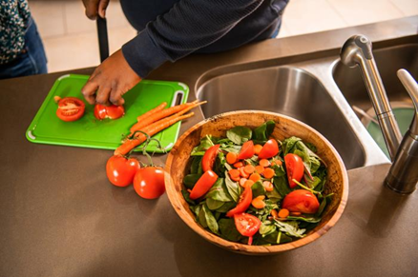

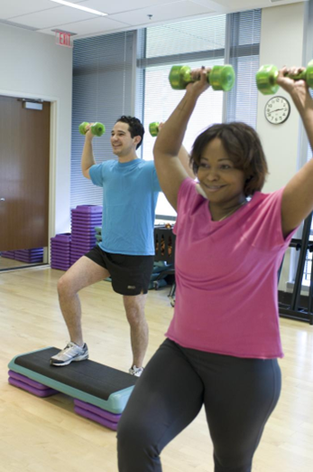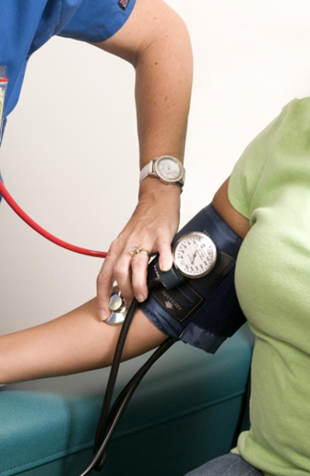





Did you know that quitting smoking/vaping makes your heart happy?
Free help may be available to you at:
- Quitline.com
- text ‘READY’ TO 31491
- or call 1-800-QUIT-NOW

¿Sabía que dejar de fumar o vapear es bueno para su corazón?
Ayuda gratuita podría estar disponible para usted en:
· Quitline.com
· Envíe un mensaje de texto que dice ‘READY’ al 31491
· O llame al 1-800-QUIT-NOW

Do you check your blood pressure at home? If so, you are in good company – 50% of adults with high blood pressure in Washington do too!
https://doh.wa.gov/you-and-your-family/illness-and-disease-z/heart-disease/manage-blood-pressure/monitor-blood-pressure

¿Usted toma su presión arterial en casa? Si es así, está en buena compañía: ¡el 50% de las personas adultas con hipertensión en Washington también lo hacen!
https://doh.wa.gov/you-and-your-family/illness-and-disease-z/heart-disease/manage-blood-pressure/monitor-blood-pressure (en inglés)

Do you take meds to manage your heart health? You’re not alone!
In Washington, meds help 75% of adults with high blood pressure and 50% of adults with high cholesterol keep their hearts healthy. Talk with your health care provider to see how you can lower your risk of heart disease and stroke.
https://doh.wa.gov/you-and-your-family/illness-and-disease-z/heart-disease/

¿Usted toma medicación para controlar la salud de su corazón? ¡No está solo!
En Washington, los medicamentos ayudan al 75% de las personas adultas con hipertensión y al 50% de las personas adultas con colesterol alto a mantener su corazón sano. Hable con su proveedor de atención médico para ver cómo puede reducir su riesgo de enfermedades cardíacas y derrames cerebrales.
https://doh.wa.gov/you-and-your-family/illness-and-disease-z/heart-disease/ (en inglés)

Every day, about 53 people in Washington are hospitalized for high blood pressure. Talk to your health care provider to avoid a trip to the ER. Learn more:
https://doh.wa.gov/you-and-your-family/illness-and-disease-z/heart-disease/manage-blood-pressure

Cada día, unas 53 personas en Washington se hospitalizan por hipertensión. Hable con su proveedor de atención médico para evitar ir a urgencias. Aprenda más: https://doh.wa.gov/you-and-your-family/illness-and-disease-z/heart-disease/manage-blood-pressure (en inglés)

Heart disease and stroke are two of the top ten causes of death in Washington.
They share a lot of common risk factors like high blood pressure, diabetes, and high cholesterol. Learn how to prevent them:
https://doh.wa.gov/you-and-your-family/illness-and-disease-z/heart-disease

Las enfermedades cardíacas y el derrame cerebral son dos de las diez principales causas de muerte en Washington.
Comparten muchos factores de riesgo comunes como hipertensión, diabetes y colesterol alto. Aprenda cómo prevenirlos: https://doh.wa.gov/you-and-your-family/illness-and-disease-z/heart-disease (en inglés)

High blood pressure in pregnancy is common—1 out of 9 pregnant people in Washington experience it. It can come with real risks. Learn more about what it means and how to manage it.
https://www.goredforwomen.org/en/know-your-risk/pregnancy-and-maternal-health
La hipertensión en el embarazo es común: 1 de cada 9 personas embarazadas en Washington la experimenta. Puede conllevar riesgos reales. Aprenda más sobre lo que significa y cómo gestionarlo.
https://www.goredforwomen.org/es/know-your-risk/pregnancy-and-maternal-health

Did you know? Staying up to date on your immunizations can help protect your heart from serious complications! Have a heart-to-heart with your doctor to see how you can protect your heart and health.
https://doh.wa.gov/you-and-your-family/immunization

¿Sabía que...? ¡Mantenerse al día con sus vacunas puede ayudar a proteger su corazón de complicaciones graves! Tenga una charla sincera con su médico para ver cómo puede proteger su corazón y su salud.
https://doh.wa.gov/es/you-and-your-family/inmunizacion

February 1-14 is Congenital Heart Defect Awareness Week. About 1 in 100 babies is born with a congenital heart defect. Learn about CHDs, treatment options, and resources for families caring for children with congenital heart disease.
https://www.heart.org/en/health-topics/congenital-heart-defects

Del 1 al 14 de febrero es la Semana de Concientización sobre los Defectos Cardíacos Congénitos. Aproximadamente 1 de cada 100 bebés nace con un defecto cardíaco congénito. Aprenda sobre los defectos cardíacos congénitos, opciones de tratamiento y recursos para familias que cuidan a niños y niñas con cardiopatía congénita.
https://www.heart.org/en/health-topics/congenital-heart-defects (en inglés)

Written Content
Include these two articles below in your organization's newsletter, bulletin, email, or other communications.

Wear Red Day is Here!
While we focus on heart health all of February, today is National Wear Red Day! Help us raise awareness of how we can lower our risk of cardiovascular disease by taking a photo of yourself or with a group showing how you are “Leading with a Healthy Heart.” Staying healthy may seem challenging, but having support makes it easier to maintain healthy habits. Even small wins – like adding 10 more minutes of physical activity to your day – can reduce risk.
Cardiovascular disease is the number one cause of death in America. Now is a great time to help each other stay active, eat healthy, and see a health care provider.
For some great tips to reduce our risk of cardiovascular disease, practice the Great 8:
- Be Active
- Eat Well
- Practice Wellness
- Check Your Blood Pressure
- Understand Your Blood Sugar Numbers
- Know Your Cholesterol Levels
- Avoid Smoking, Vaping and Alcohol
- Follow Your Doctor’s Recommendations
Created by the Heart Disease, Stroke, and Diabetes Prevention unit, the Great 8 is a visual-based tool created to improve communications around cardiovascular health between health professionals and patients, especially patients who can benefit from learning more about their health, and English language learners. It is available in an English mobile and desktop version as well as 26 other languages.
Download the PDFs to learn more about each of the steps.

Use Building Lights to Show Your Support for Wear Red Day
Help raise awareness of women’s heart and brain health by turning the lights red on Feb. 5 and 6!
National Wear Red Day is the first Friday in February. It’s an annual moment to raise awareness of heart disease and stroke as leading causes of death in women and encourage individuals and communities to take action to protect their heart health.
Your building can join landmarks across the country in bringing attention to this issue. By igniting a wave of red across the state, we can send a powerful reminder to women that heart disease is preventable and beatable.
The commitment is simple: buildings are asked to flip their lights red by Thursday, Feb. 5, and to remain red throughout Friday, Feb. 6. Some buildings choose to stay red throughout February, American Heart Month. For more resources on Heart Month, visit CDC, NIH, and the American Heart Association.

Downloadable and Orderable Digital Resources

Heart Attack and Stroke and Blood Pressure Management – Multiple Languages
We have a host of materials available for order for heart disease, stroke, and blood pressure management, many in several languages!
- Signs and Symptoms of Heart Attack and Stroke (36 languages)
- Free blood pressure tracker cards, blood pressure brochures, how-to manuals, and more (multiple languages)
- Our website has videos and other resources for blood pressure management (multiple languages)
Want to see a language added? Contact us at HeartDisease@doh.wa.gov.

Great 8 – Multiple Languages
The “Great 8” is our flagship health communications tool to help you prevent heart disease and stroke in your communities. Designed to be simple but effective, it increases health literacy by helping people choose from eight health behaviors core to cardiovascular disease prevention and management. It is designed for people with gaps in health education and English language learners.
View Great 8 materials in English, Spanish, and 25 other languages spoken in Washington.
For more information about using Great 8, or to receive training on Great 8 in Spanish or English, and other resources, email HeartDisease@doh.wa.gov.

Washington Resources

Cardiovascular Connection
The Cardiovascular Connection is a website for health care providers and team members to support their patients in improving cardiovascular health. The site includes videos to teach how to self-monitor blood pressure, ways that health care practices can be recognized for their efforts to improve the health of their patients, and updates on state and national efforts, including awareness campaigns for different audiences. The Cardiovascular Connection is also the home of Great 8.

2-1-1
211 is a free, confidential, multilingual helpline. It is your one-stop connection to local community services from utility assistance, food, housing, healthcare, elder care, childcare, after-school programs, mental health supports, and much more. Visit WA 211 or dial 211 in Washington to contact a resource specialist.

Training for Community Health Workers
Interested in training – in-person or virtual? Washington’s Community Health Worker Training Program and the Heart Disease, Stroke, and Diabetes Prevention Program offer training to improve your ability to help communities manage blood pressure and other conditions that can impact heart health. Email heartdisease@doh.wa.gov.

EthnoMed
EthnoMed is Harborview Medical Center's ethnic medicine website for medical and cultural information about immigrant and refugee groups. It is specific to groups in the Seattle area, but much of the cultural and health information is of interest and can be used in other geographic areas. One resource available on EthnoMed is a visual guide to sodium in foods.

National Resources
American Heart Association

Resources in Multiple Languages
- High Blood Pressure Tools and Resources (English, Spanish, Simplified Chinese, Traditional Chinese.)
- Printable blood pressure trackers (multiple languages)
- Patient education sheets: English| Spanish
- Lower Your High Blood Pressure Fact Sheet: English | Spanish

News and Articles from AHA
- Go Red for Women from the American Heart Association: Washington State Activities
- What is CPR: American Heart Association
- Updated CPR guidelines: tackle choking response, opioid-related emergencies, and revised chain of survival
- Highlights of the 2025 AHA Guidelines for CPR and ECC
- Gum disease may be linked to plaque buildup in arteries, a higher risk of major Cardiovascular Events

Centers for Disease Control and Prevention
- Blood Pressure home page
- Cholesterol home page
- Million Hearts Campaign
- Live to the Beat Campaign

National Heart, Lung, and Blood Institute
- American Heart Month
- High Blood Pressure health topic page

American Diabetes Association

